<Self Introduction/>

|  |  |
| --- | --- |
| Name | Arshdeep Singh |
| ID | #133462176 |
| Email | asingh568@myseneca.ca |
| Program | Honours Bachelor of Technology  - Software Development (BSD) |

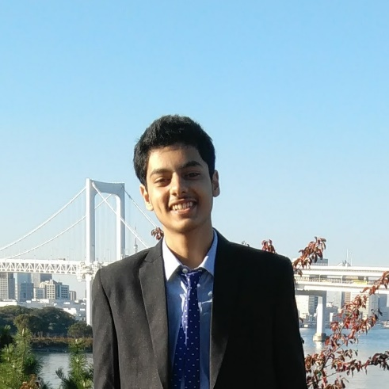

# **Interests/Hobbies**

* background-color: #21D4FD; background-image: linear-gradient(19deg, #21D4FD 0%, #B721FF 100%);
* Srfdgh
* asfg

# **Skills**

* easg
* aevrsg
* sdsfg

# **Career aspiration**

* earg
* cdvdbgh
* sdsfg